How to Use KPIs to Set Goals That Actually Work
Introduction
This document is your new playbook for goal setting. We're going to kill the idea of "hoping" for results and replace it with a system of projecting and hitting your numbers with precision. You're going to learn how to stop being a passenger in your own business and start being the pilot.

By the end of this, you'll understand the handful of metrics that actually drive your business forward. You'll know how to reverse-engineer your income goals into daily, trackable actions, and you'll finally have a clear, data-backed answer to the question: "What do I need to do today to hit my goals this year?"

Fundamentals: The Why Behind the Numbers
Most loan officers operate on gut feelings and referrals. They're walking through a fog, celebrating the deals that fall into their lap and getting frustrated when the pipeline dries up. They have no idea what's working, what's broken, or where their next deal is coming from. This is not a business; it's a gamble.

When you want to scale and you just throw more money at ads or leads, the whole thing breaks. Why? Because you didn't know that 90% of your leads were unqualified garbage and you just got lucky on a couple of them. You didn't know your follow-up was broken. You didn't know your proposals were getting stuck. You were operating blind.

Your business is a machine. Each part of that machine does something specific. If you try to shove more input into a broken machine, it doesn't produce more output—it just breaks faster.

Why KPIs Matter: The Two Non-Negotiables
There are two reasons—why you need to track KPIs:

Reason #1: Measure What's Working and What's Broken So You Can Fix It

Without KPIs, you're guessing. You don't know if your problem is lead quality, follow-up speed, sales skills, or operational execution. You're just throwing spaghetti at the wall and hoping something sticks. Research shows that sales teams using data-driven goal-setting are 2.3x more likely to achieve their goals, while 64% of sales leaders lack the accuracy to even forecast their performance.

KPIs give you a diagnosis. They tell you exactly where the leak is in your funnel. Is it lead-to-qualified? That's a marketing problem. Is it qualified-to-conversation? That's a follow-up problem. Is it conversation-to-proposal? That's a sales skills problem. Is it submission-to-funding? That's an operations problem. You can't fix what you can't see.

Reason #2: Create Predictability in Your Business

Once you know your numbers, your business stops being a mystery and starts being a machine. You know that if you put in 100 leads at a $50 cost per lead, and your conversion rates are X, Y, and Z, you will get N funded loans and $M in commissions. That's not a goal—that's a projection.

This is the difference between hoping you hit your income target and knowing you will. Companies using data-driven goal-setting tools achieve 27% higher goal attainment and 35% better forecast accuracy. 3 Predictability is what allows you to scale. It's what allows you to hire. It's what allows you to sleep at night.

The Two-Part System: KPIs + Goal Reversal
Understanding your KPIs is only the first part of the playbook. Once you have clarity on your numbers, you can do something powerful: reverse-engineer your goals into daily, actionable steps.

This is the Goal Reversal Framework. It's a simple 4-step process:

- Define the Macro Outcome: What is your annual income goal? Be specific. (e.g., "I will earn $250,000 in commissions this year.")
- Identify the Core KPIs: What are the critical conversion points in your sales process? These are the levers you can pull to influence the final outcome.
- Calculate the Micro Inputs: Work backward from your income goal to determine the exact number of leads, conversations, proposals, and submissions you need each month, week, and day.
- Track and Adjust Relentlessly: Your KPIs are your dashboard. If a number is off, you don't panic—you diagnose the problem and fix it. This is the difference between being a professional and an amateur.

This process transforms your business from a black box into a predictable machine. You'll know that for every $X you put in, you get $Y out. And when you break down a $250,000 annual goal into "I need 2 qualified conversations today," it becomes undeniably impossible not to hit your goal.

Best Practices
#1: Master Your Core Funnel KPIs
Principle: You can't fix what you don't measure.

Why it matters: Your sales process is a funnel, not a collection of random activities. Each stage has a conversion rate, and small improvements at each stage have a massive compounding effect on your final output. Ignoring these numbers is professional malpractice.

What to do:

- Automated: Your CRM (like GHL) should be configured to automatically track the conversion rate between each of these stages. This is non-negotiable.
- Manual: You must review your KPI dashboard daily and weekly. This is not optional.

Here are the non-negotiable KPIs for a loan officer:

KPI | Description | Why It Matters
Lead to Qualified Lead % | The percentage of new leads that meet your minimum qualification criteria. | Tells you if your marketing is attracting the right people. A low percentage means you're wasting money on bad leads.
Qualified Lead to Conversation % | The percentage of qualified leads you actually have a meaningful conversation with. | Measures the effectiveness of your speed-to-lead and initial outreach. A low number here means your follow-up is broken.
Conversation to Proposal % | The percentage of conversations that result in a formal loan proposal or application. | Shows how well you build trust and articulate value. If this number is low, your sales skills need work.
Proposal to Submission % | The percentage of proposals that are submitted to underwriting. | Indicates the quality of your proposals and your ability to guide clients through the application process.
Submission to Funding % (Pull-Through Rate) | The percentage of submitted loans that actually close and fund. | This is the ultimate measure of your operational efficiency and ability to solve problems. A low pull-through rate is a massive red flag. 4
Common Mistakes:

- Only tracking funded loans. This is like only looking at the final score of a football game without watching any of the plays.
- Blaming lead quality for everything. A low lead-to-qualified ratio is a marketing problem. A low qualified-to-conversation ratio is a sales process problem. Know the difference.
- Using a spreadsheet instead of a CRM. This is amateur hour. Your CRM is your single source of truth.

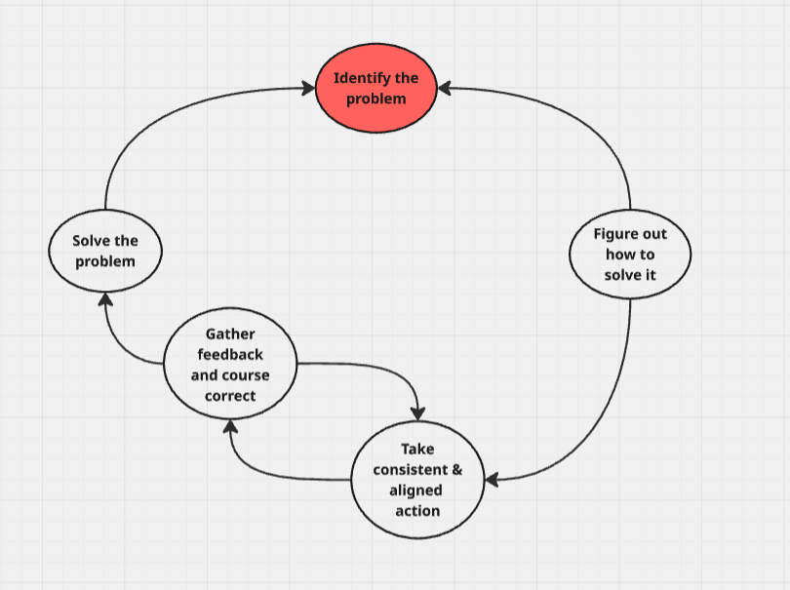

KPIs to Track:

- Conversion rate at each of the 5 stages above.
- Cost Per Lead (CPL)
- Cost Per Funded Loan (CPL / (Lead to Qualified % × Qualified to Conversation % × Conversation to Proposal % × Proposal to Submission % × Submission to Funding %))

#2: Reverse Engineer Your Goals into Daily Actions
Principle: Big goals are achieved through small, consistent actions.

Why it matters: An annual income goal of $250,000 is paralyzing. A daily goal of having 2 qualified conversations is actionable. Breaking down the macro outcome into micro inputs makes the goal achievable and creates a clear path to success. Research shows that employees who set time-bound goals and report on them weekly achieve 40% more than those who don't. 5

What to do:

- Use the "Goal Reversal Calculator" (provided in the assets section) to work backward from your income goal.
- Start with your desired annual income and your average commission per deal.
- This will tell you how many funded loans you need per year and per month.
- Plug in your current conversion rates for each KPI stage.
- The calculator will spit out the exact number of leads, conversations, and proposals you need each month, week, and day.

Wrong Way vs. Right Way Example:

- Wrong Way: "My goal is to close 5 deals this month." (This is a wish, not a plan.)
- Right Way: "To close 5 deals this month, based on my 50% submission-to-funding rate, I need 10 submissions. Based on my 80% proposal-to-submission rate, I need 12.5 proposals. Based on my 25% conversation-to-proposal rate, I need 50 qualified conversations. That's about 2-3 qualified conversations every single workday. My only focus today is to have 2 qualified conversations."

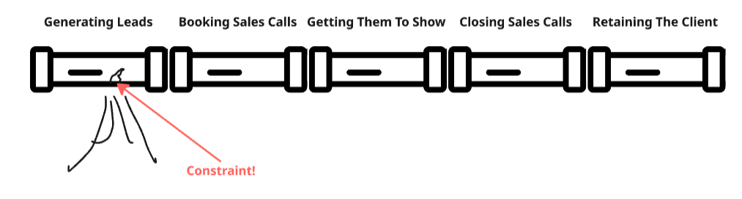
#3: Make Your Data Visible and Accountable
Principle: What is inspected gets respected.

Why it matters: Accountability improves goal achievement by up to 65%. 5 If you are the only person who knows your numbers, you are playing a dangerous game. You need to create a system of accountability, even if you are a team of one.

What to do:

- Automated:
  - Set up a dashboard in your CRM that is always visible on your screen.
  - Create automated reports that are emailed to you and your manager/coach every morning.
- Manual:
  - Have a weekly KPI review meeting with your manager, a peer, or a coach.
  - Post your weekly numbers in a dedicated Slack channel.

Common Mistakes:

- Hiding from your numbers when you have a bad week. This is when you need to look at them the most.
- Waiting until the end of the month to see if you hit your goal. By then, it's too late. Companies that set and review goals quarterly generate 31% more returns than those who review annually. 6

KPIs to Track:

- Your daily/weekly/monthly progress against your reverse-engineered targets.

Assets / Templates
- Goal Reversal Calculator (Google Sheet)
  - Location: [LINK TO GOOGLE DRIVE]

Implementation Notes
- CRM Setup (GHL):
  - Ensure your GHL pipeline stages exactly match the 5 Core Funnel KPIs.
  - Create a custom dashboard that displays the conversion rate between each stage in real-time.
  - Set up an automated workflow that sends you a daily summary of your pipeline movement.
- Weekly Cadence:
  - Monday (15 mins): Review the previous week's KPIs. Identify the biggest bottleneck.
  - Friday (15 mins): Review the current week's progress. Adjust your focus for the following week based on the data.

Improvement Loop
Ask yourself this question at the end of every single week:

"Which KPI had the biggest drop-off this week, and what is one specific action I can take next week to improve it?"

